RaktSetu: UML Design Document
Expiry-aware blood redistribution network
PRITIKA KHANDELWAL

Overview
Eight UML diagrams describe RaktSetu: one use case diagram, one package diagram, five class diagrams and one sequence diagram. They are written in PlantUML, kept in docs/uml/ of the repository, and updated in the same change as the code they describe.
# | Diagram | Type | Shows
1 | Use cases | Use case | The three actors and what each can do
2 | Packages | Package | How the modules depend on each other
3 | Domain model | Class | Components, facilities, inventory, interfaces, exceptions
4 | Decision engine | Class | Allocation, expiry risk, transfer strategies
5 | Emergency request | Sequence | One request from the hospital to issued units
6 | Security and monitoring | Class | Sign-in lockout, health check, metrics, concurrency
7 | Urgent alerts | Class | Alert channels and the transactional outbox
8 | Demand forecasting | Class | Forecasters and how the engine uses them
Notation. A hollow triangle on a solid line is inheritance (extends); on a dashed line it is interface implementation (implements). A filled diamond is composition (the part cannot exist without the whole), a hollow diamond is aggregation. A plain arrow is an association, a dashed arrow a dependency. + is public, - private, # protected; underlined members are static.

1. Use case diagram
Three human roles and two external systems use RaktSetu; each role sees only the use cases its job needs.
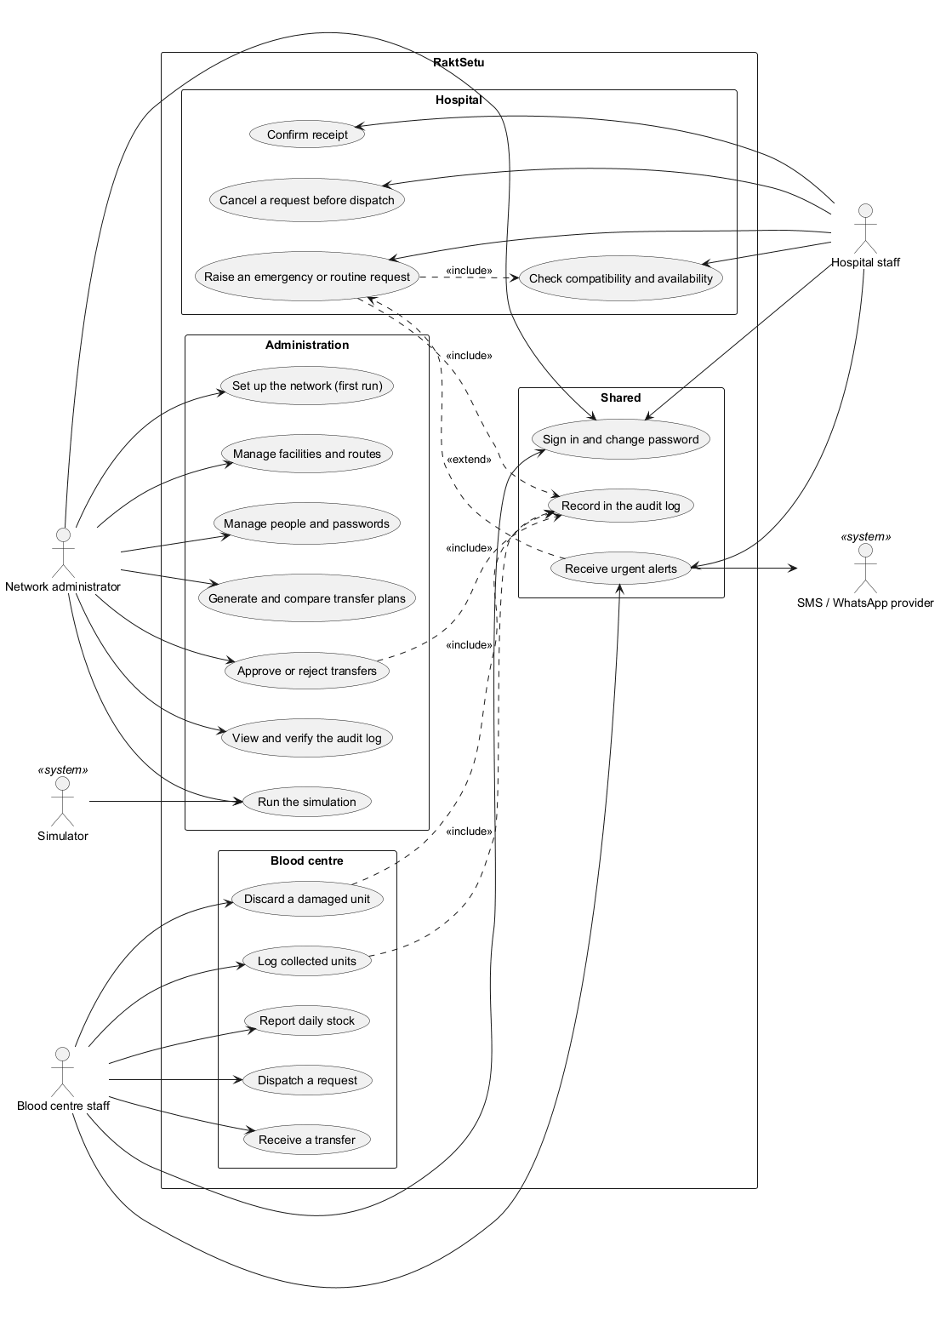
- Network administrator: sets up the network, manages facilities, routes and people, plans and approves transfers, verifies the audit log, and runs the simulation.
- Blood centre staff: log collected units, report daily stock, dispatch requests, receive transfers and discard damaged units.
- Hospital staff: raise emergency or routine requests, cancel them before dispatch, confirm receipt, and check compatibility and availability.
- Simulator (system actor) runs the digital twin; the SMS / WhatsApp provider (system actor) delivers urgent alerts.
Raising a request always includes a compatibility check and an audit record; approving a transfer, logging units and discarding a unit also include an audit record. Urgent alerts extend raising a request: they are sent only when a recipient has turned them on.
Source: docs/uml/use-case.puml.

2. Package diagram
The modules form layers with no cycles: the domain model depends on nothing, and every front end reaches it through the same engine.
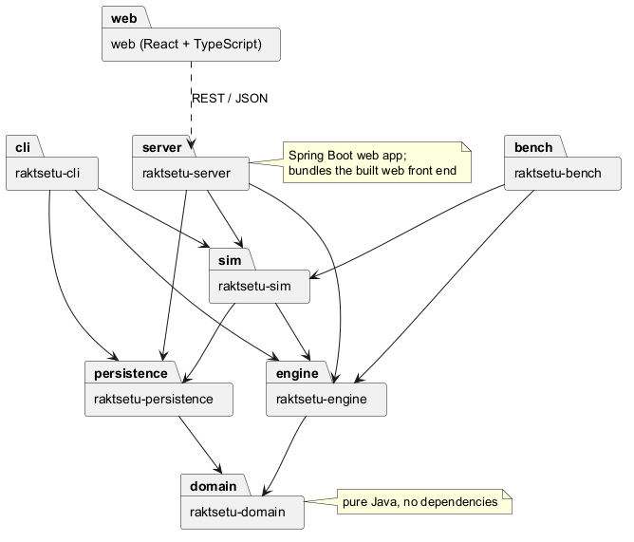
Module | Depends on | Role
raktsetu-domain | nothing | Components, facilities, inventory, compatibility rules, exceptions
raktsetu-engine | domain | Allocation, expiry risk, forecasting, transfer strategies
raktsetu-persistence | domain | CSV files and the hash-chained audit file
raktsetu-sim | domain, engine, persistence | Simulator and digital twin
raktsetu-cli | engine, persistence, sim | The 16-option console app (course V1)
raktsetu-server | engine, persistence, sim | Spring Boot web app, database, security
raktsetu-bench | engine, sim | Benchmarks and the load test
web | server (over REST) | React front end, bundled into the server
Layering keeps the design testable: the engine is tested without a database or web server, and a change to the web layer cannot break a business rule.
Source: docs/uml/packages.puml.

3. Domain class diagram
The domain model is where the four OOP pillars live: two abstract class hierarchies, small interfaces, immutable records and a checked exception hierarchy.
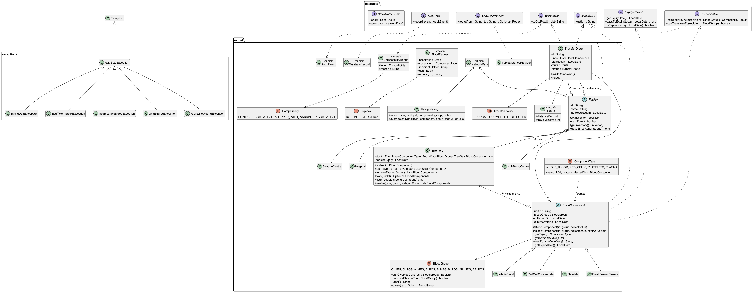
- Inheritance and polymorphism: BloodComponent is abstract, with WholeBlood, RedCellConcentrate, Platelets and FreshFrozenPlasma as subclasses; each supplies its own shelf life and storage condition. Facility is abstract, with HubBloodCentre, StorageCentre and Hospital; each answers canStore() and canCollect() for itself.
- Interfaces: BloodComponent implements Identifiable, ExpiryTracked and Transfusable; TransferOrder implements Identifiable and Exportable; TableDistanceProvider implements DistanceProvider. Each interface is small and has a single purpose.
- Composition and aggregation: a Facility owns exactly one Inventory (filled diamond); the inventory holds any number of units in first-expiry-first-out order (hollow diamond), because units exist independently and move between facilities.
- Associations: a TransferOrder links a source and a destination facility to one or more units, with a TransferStatus.
- Values: Route, BloodRequest, AuditEvent, WastageRecord, NetworkData and CompatibilityResult are immutable records; BloodGroup, ComponentType, Compatibility, Urgency and TransferStatus are enums.
- Exceptions: RaktSetuException is the checked base class for InsufficientStockException, IncompatibleBloodException, UnitExpiredException, FacilityNotFoundException and InvalidDataException.
Source: docs/uml/domain-classes.puml.

4. Engine class diagram
The decision engine shows the Strategy and Template Method patterns working together to plan transfers.
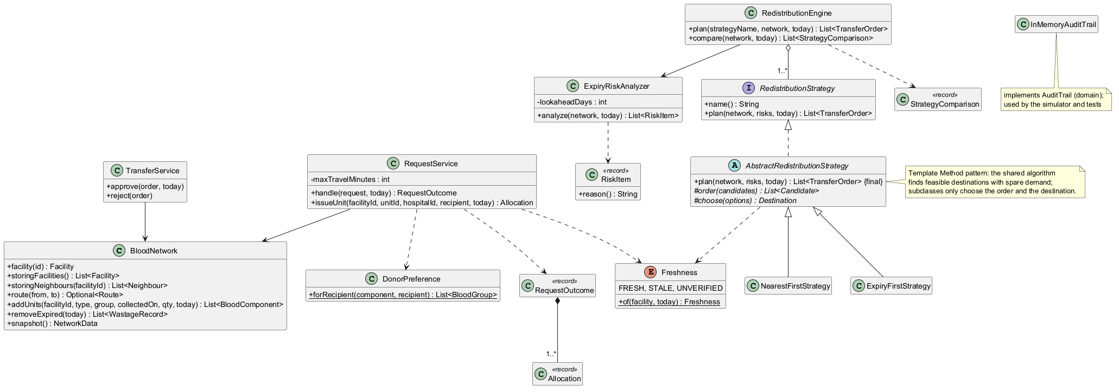
- BloodNetwork holds the facilities, routes, usage history and wastage; RequestService and TransferService act on it.
- Allocation: RequestService serves a request using DonorPreference (which donor groups to try, in order) and returns a RequestOutcome composed of one or more Allocation records.
- Risk: ExpiryRiskAnalyzer produces RiskItem records: the units unlikely to be used before they expire.
- Strategy pattern: RedistributionStrategy is the interface the administrator chooses through; RedistributionEngine aggregates one or more strategies and can compare them (StrategyComparison).
- Template Method pattern: AbstractRedistributionStrategy.plan() is final and fixes the planning algorithm; NearestFirstStrategy and ExpiryFirstStrategy supply only how candidates are ordered and which destination is chosen.
- Data freshness: Freshness (fresh, stale, unverified) decides whether a centre's reported stock can be trusted.
Source: docs/uml/engine-classes.puml.

5. Sequence diagram: an emergency request
An emergency request is served from the nearest compatible stock, soonest-expiring first, or refused with a clear reason; nothing is issued in part.
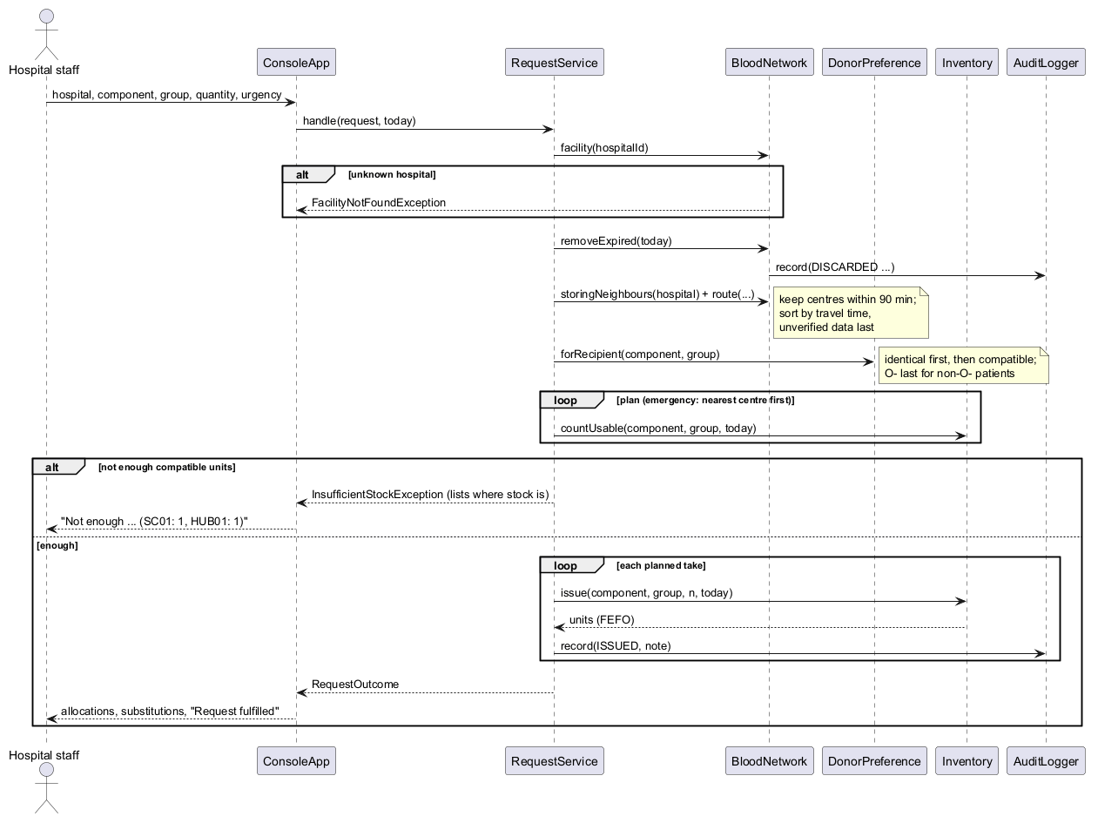
- Hospital staff enter the hospital, component, blood group, quantity and urgency; the app calls RequestService.handle().
- An unknown hospital ends the request with FacilityNotFoundException.
- Expired units are removed first, and each removal is recorded in the audit log.
- Candidate centres are the hospital's storing neighbours within 90 minutes, sorted by travel time, with unverified data last.
- DonorPreference gives the donor groups to try: identical first, then compatible, O− last for non-O− patients.
- The service counts usable units to plan the issue. If there are not enough, it throws InsufficientStockException, which lists where stock exists.
- Otherwise it issues units in first-expiry-first-out order, records each issue in the audit log, and returns the allocations.
The diagram shows the console app as the caller; in the web app, WorkflowService makes the same call to the same engine.
Source: docs/uml/sequence-emergency-request.puml.

6. Security and monitoring class diagram
The server's sign-in protection, health check, metrics and concurrency each sit behind an interface or a small class with one job.
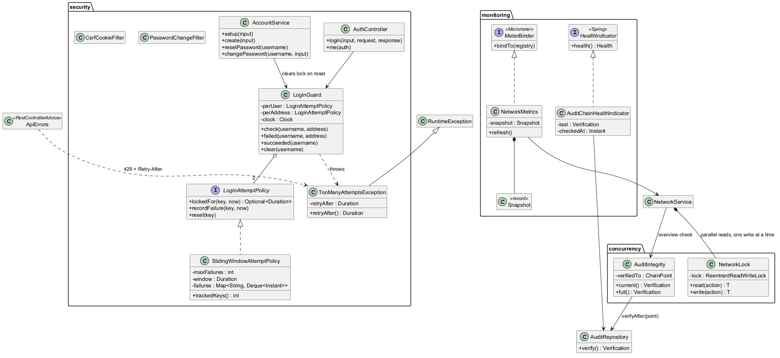
- Sign-in lockout (Strategy): LoginGuard holds two LoginAttemptPolicy objects, one per account and one per address, both SlidingWindowAttemptPolicy. Too many failures throw TooManyAttemptsException, which carries retryAfter; ApiErrors turns it into HTTP 429 with a Retry-After header. An administrator's password reset clears the account's lock.
- Monitoring: AuditChainHealthIndicator implements Spring's HealthIndicator and reports DOWN if the audit hash chain was edited; NetworkMetrics implements Micrometer's MeterBinder and publishes network gauges from an immutable Snapshot.
- Concurrency: NetworkService owns a NetworkLock (a fair readers-writer lock): reads run in parallel and each change runs alone. AuditIntegrity checks only audit entries written since its last check.
Source: docs/uml/server-security-monitoring.puml.

7. Urgent alerts class diagram
Urgent SMS and WhatsApp alerts combine three patterns: Strategy for the channels, Template Method for their shared HTTP code, and a transactional outbox for reliable delivery.
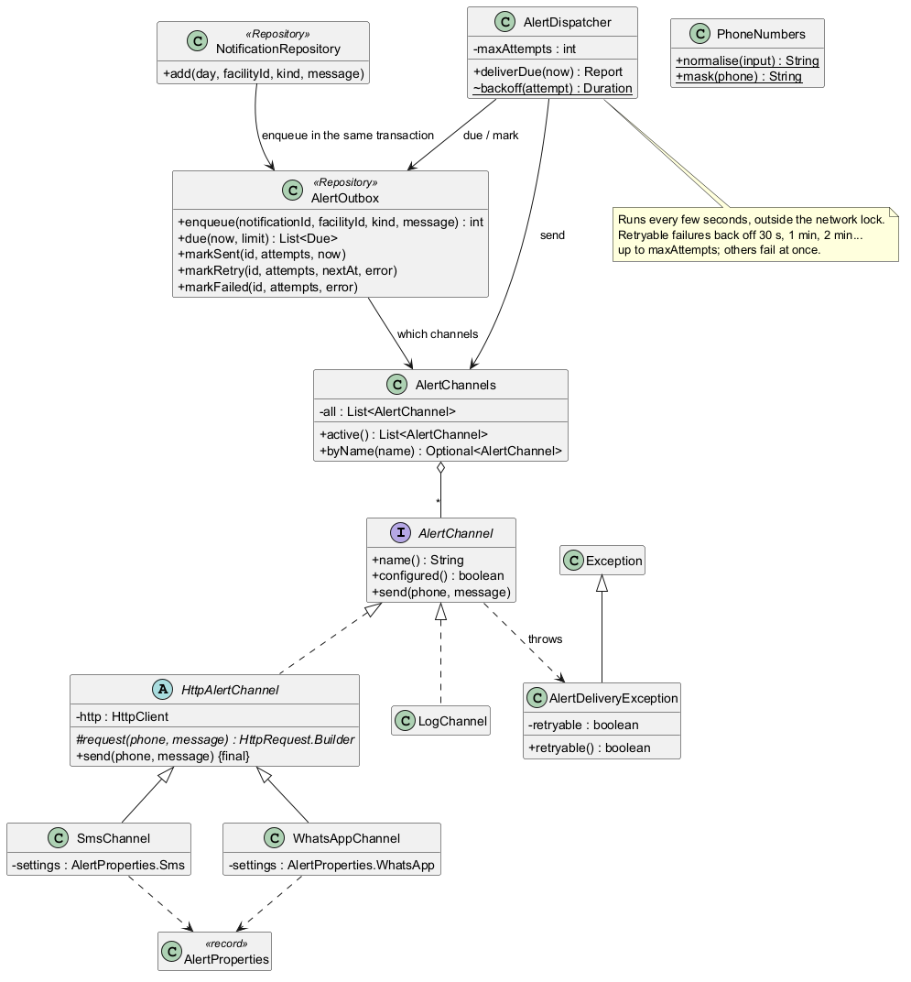
- Strategy: AlertChannel is the interface; SmsChannel (Twilio), WhatsAppChannel (Meta Cloud API) and LogChannel implement it. AlertChannels aggregates every channel and picks the configured ones, or the log when none is configured.
- Template Method: HttpAlertChannel.send() is final and shares timeouts and error handling; each subclass supplies only its provider's request.
- Transactional outbox: NotificationRepository.add() asks AlertOutbox to queue alerts in the same database transaction as the notification, so a change that rolls back sends nothing. AlertDispatcher later sends due alerts, retrying after 30 s, 1, 2 and 4 minutes.
- Exceptions with state: AlertDeliveryException.retryable tells the dispatcher whether trying again could help.
Source: docs/uml/alerts.puml.

8. Demand forecasting class diagram
Demand forecasting is a Strategy with a factory: each forecaster creates a Forecast object, and the risk check and the planner use whichever forecaster they are given.
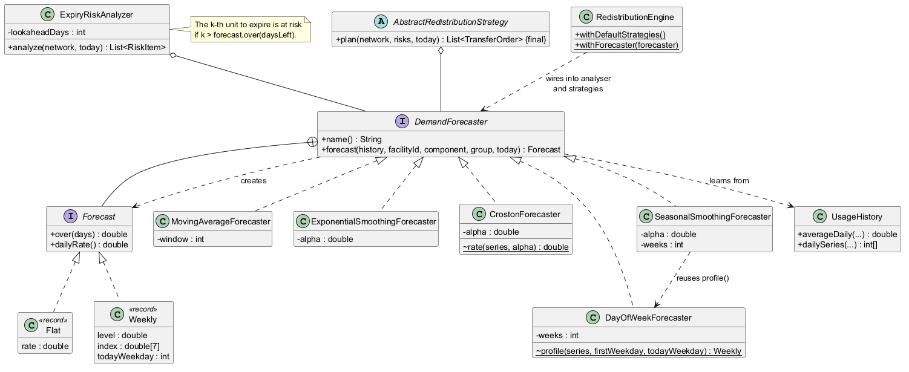
- Strategy: DemandForecaster is implemented by MovingAverageForecaster, ExponentialSmoothingForecaster, CrostonForecaster, DayOfWeekForecaster and SeasonalSmoothingForecaster.
- Factory: forecast() returns a Forecast (a nested interface) implemented by the records Flat and Weekly; it answers "expected demand over the next n days" for any n.
- Use: ExpiryRiskAnalyzer and AbstractRedistributionStrategy each hold a forecaster (aggregation); RedistributionEngine.withForecaster() wires one forecaster into both.
- Reuse: SeasonalSmoothingForecaster reuses DayOfWeekForecaster's weekday profile, and every forecaster learns from UsageHistory.
With the default moving-average forecaster, the engine gives exactly the same results as before forecasting was added; this was checked by comparing simulation output byte for byte.
Source: docs/uml/forecasting.puml.

